Contents

Almond 3

Apple 4

Apricot 5

Ash tree 6

Avocado 7

Beech tree 8

Blueberry 9

Cannabis 10

Cacao 11

Cedar 12

Cherry 13

Citrus – general 14

Coffee 15

Corn 16

Cotton 17

Cypress 18

Dates 19

Eucalyptus 20

Fig 21

Fir (Douglas Fir tested) 22

Grape – Wine and Table 23

Grapefruit 24

Hazelnut 25

Kiwi 26

Lemon 27

Lime 28

Lychee/longan 29

Macadamia 30

Mandarin orange 31

Mango 32

Maple 33

Oak 34

Olive 35

Orange 36

Peach/nectarine 37

Pear 38

Pecan 39

Pepper (Bell pepper tested) 40

Persimmon 41

Pine 42

Pistachio 43

Pomegranate 44

Pomelo 45

Prune/plum 46

Redwoods 47

Soil 48

Soybean 49

Spruce 50

Tobacco 51

Tomatoes 52

Walnut 53

# Almond

Performance:

* Excellent. Recommended for commercial use.
* Sensor data matches the pressure chamber, but can read 1-3 bars wetter during the spring.
* Thoroughly validated and used commercially.

Installation tips:

* Install after leaf out, on a 2+” branch. Installation into main trunk can be difficult if the bark is thick. Big and small sensors can work well.
* Sensors should be reinstalled after the winter, otherwise SWP will read too wet.

Troubleshooting:

* Sensor install site can get blocked and sensor will read too wet, with little to no diurnal pattern. Reinstall.
* Sensors can get disconnected from xylem due to breaks in the mating compound. The sensors will then read very negative values during hot part of day. Reinstall.

Guidelines:

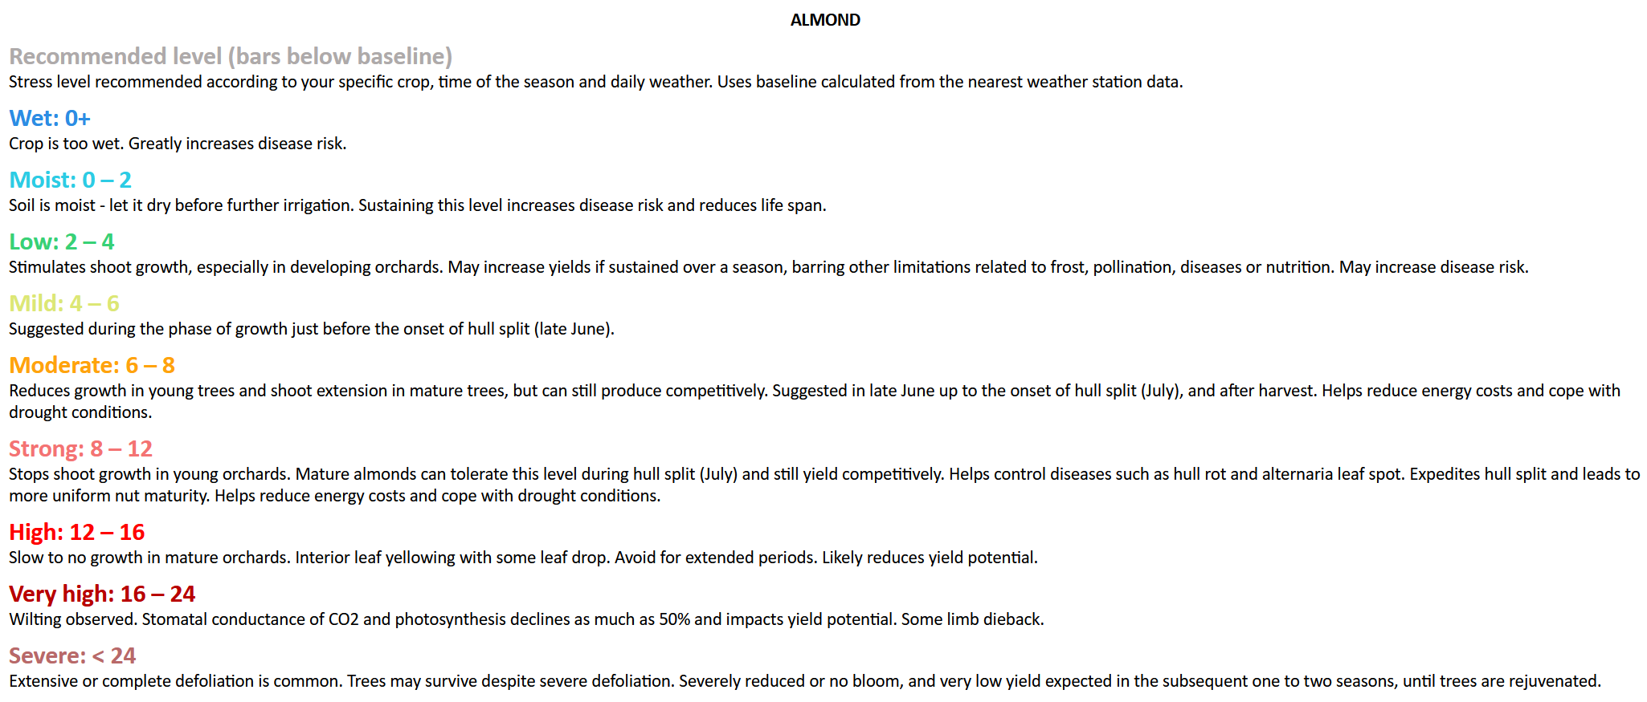

References:

* [Using the Pressure Chamber for Irrigation Management in Walnut, Almond, and Prune](https://anrcatalog.ucanr.edu/pdf/8503.pdf)

# Apple

Performance:

* Excellent. Recommended for commercial use.
* Sensor data matches the pressure chamber.
* Thoroughly validated and used commercially.

Installation tips:

* Very easy install, apple xylem is usually uniform and healthy.
* Ensure the bubble wrap insulation is loose so that excess moisture can evaporate, particularly important in wetter climates.
* Sensors may freeze during the winter if temperatures go below 0 °C
* Big or small sensors can work well, depending on the trunk diameter.

Troubleshooting:

* Main issue seen is sensors reading 0 when trunk is wet. Attach insulation loosely to allow evaporation.

Guidelines:

* Not yet established. Recommend irrigation by SWP trend.

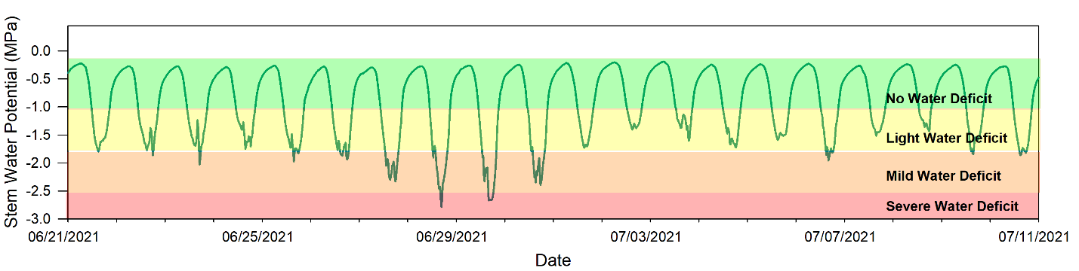

[Sample guidelines for apple from Washington State University](https://treefruit.wsu.edu/microtensiometers-a-new-tool-to-monitor-your-apple-trees-for-deciding-when-and-how-much-to-irrigate/)

References:

* [Microtensiometers: a new tool to monitor your apple trees for deciding when and how much to irrigate](https://treefruit.wsu.edu/microtensiometers-a-new-tool-to-monitor-your-apple-trees-for-deciding-when-and-how-much-to-irrigate/)
* [Trunk Water Potential Measured with Microtensiometers for Managing Water Stress in “Gala” Apple Trees](https://www.mdpi.com/2223-7747/12/9/1912)

# Apricot

Performance:

* Untested, but sensors generally work well in stone fruits.

# Ash tree

Performance:

* Untested.

Installation tips:

* Likely will need to use thick-bark installation method.

# Avocado

Performance:

* Use not recommended at the moment.
* Normal sensor installation usually gets flooded and reads zero.
* Heading cut installation is being tested to solve this issue.

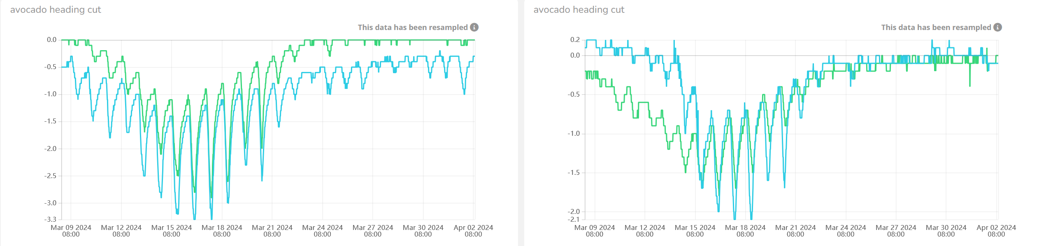

Figure 1 Typical behavior seen in avocado. Heading cut install.

# Beech tree

Performance:

* Recommended for experimental use.
* Initial testing showed two sensors installed into same tree measured SWP and agreed with each other. More testing needed.

Installation tips:

* Use thick-bark installation method.

# Blueberry

Performance:

* Recommended for experimental use.
* Initial testing of small probes shows consistently good data that matches the pressure chamber trend. Still under testing.

Installation tips:

* Recommend using the smallest, 2mm sensors for most blueberries due to small trunk size.

References:

* [Irrigation of Blueberry, David Bryla](https://cdn.blueberriesconsulting.com/2015/07/pdf_000037.pdf)

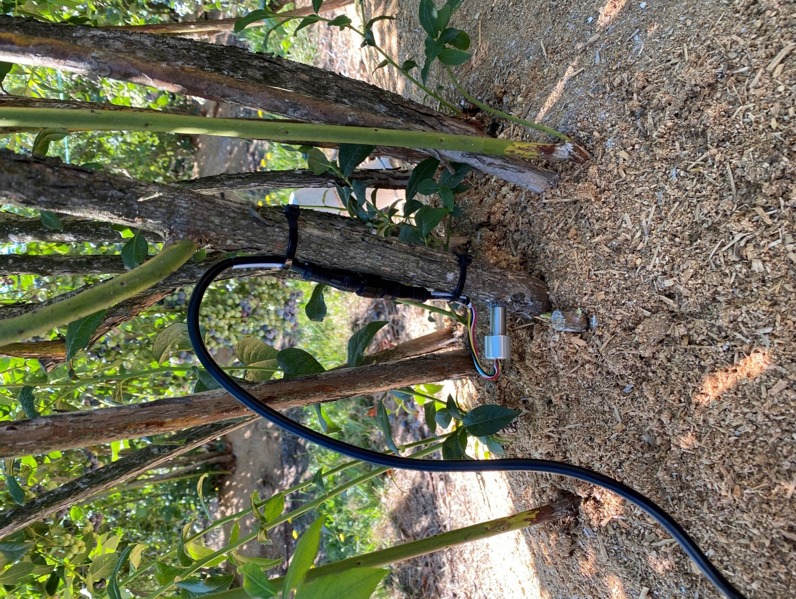

# Cannabis

Performance:

* Small probes installed shallowly give reasonable data and agree with each other.
* Recommended for experimental use.

Installation tips:

* Installation requires care because hemp stem is soft and hollow.

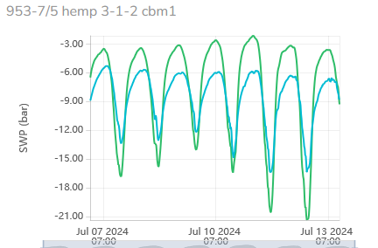

# Cacao

Performance:

* Not recommended at the moment.
* Initial testing of small probes in potted trees showed sensors get flooded and read zero after a week or so.
* Heading cut install may help with this issue, but needs to be tested in larger trees.

# Cedar

Performance:

* Untested.

Installation tips:

* Should use thick-bark tree installation method.

# Cherry

Performance:

* Recommended for experimental and commercial use.
* Guidelines are still missing, so irrigation should follow sensor trend and grower experience.
* Good results seen in research and commercial orchards.

Installation tips:

* Similar to almond, sensors should be installed in scaffolding branches, after leaf-out.
* Reinstall sensors after the winter for best results. Sensors may freeze in < 0 °C temperatures.
* Big or small probes will work well.

Troubleshooting:

* Limited testing in cherry. Likely to see similar issues to almond.

# Citrus – general

Performance:

* Recommended for experimental use only.
* Testing in citrus has shown mixed results. Many sensor installations work properly, but some customers have seen sensors get flooded and measure zero, or odd data. We are investigating this issue.

Installation tips:

* Recommend using small probes because sensor removal/reinstallation is easier.

Troubleshooting:

* If sensor readings appear non-sensical, recommend removing and reinstalling sensor.

# Coffee

Performance:

* Recommended for experimental use, and initial commercial testing.
* Initial results are very promising, data is consistent, and correlates well with the pressure chamber, though the measurements are somewhat different. We are exploring the reasons for this discrepancy.

Installation tips:

* Shallow installation with the new small probe design is likely critical. Requires small probes.

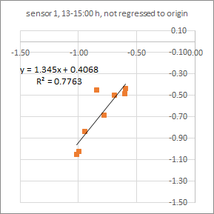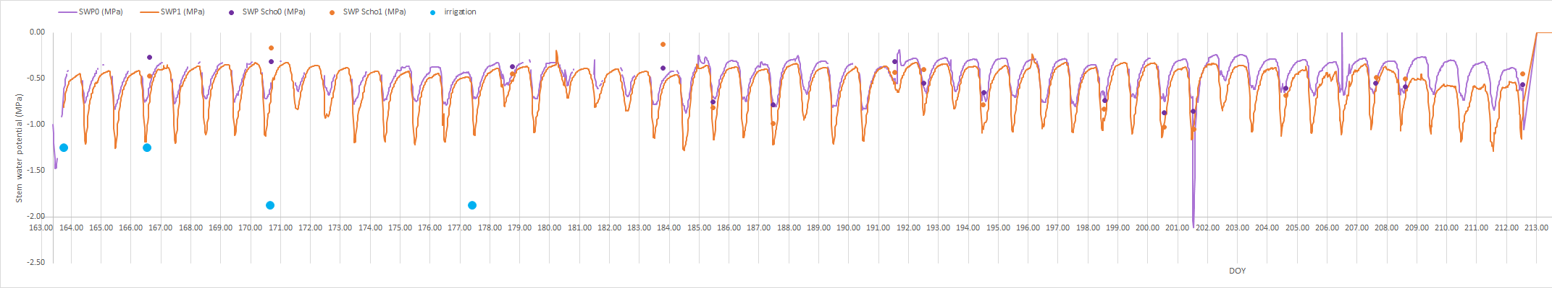

Preliminary data courtesy of Teresa Afonso do Paço.

# Corn

Performance:

* Small probes installed shallowly give reasonable data and agree with each other.
* Recommended for experimental use.

Installation tips:

* Installation requires care because corn stalk is soft.

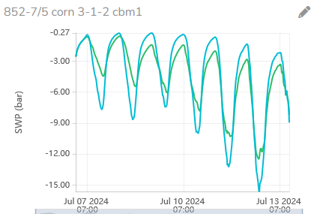

# Cotton

Performance:

* Recommended for experimental use and initial commercial field trials.
* Sensor measurements fit the pressure bomb very well, but some variability seen across years.

Installation tips:

* Recommend using the smallest 2 mm sensor due to small trunk size of cotton.

References:

* [Bomb Your Cotton for Maximum Profit!!](https://www.pmsinstrument.com/resources/bomb-your-cotton-for-maximum-profit/)
* [Monitoring cotton water status with microtensiometers](https://link.springer.com/article/10.1007/s00271-024-00930-w)

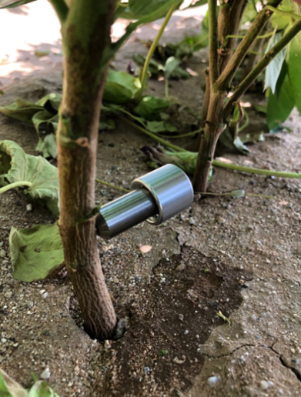

# Cypress

Performance:

* Untested.

Installation tips:

* Will need to use thick-bark installation method.
* Psychrometry has been used to measure SWP in this species, so microtensiometers will very likely work as well.

# Dates

Performance:

* Untested.

Installation tips:

* Installation method needs to be developed due to date palm’s unique trunk structure. It may be possible to install sensors into leaf stem.

# Eucalyptus

Performance:

* Untested.

# Fig

Performance:

* Recommended for experimental and commercial field trials.
* Sensor measurements fit the pressure bomb very well.

Troubleshooting:

* Fig and related species are known for producing lots of latex. The latex generally does not interfere with sensor measurement. But if sensor is installed too shallowly, latex may block measurement and the sensor should be reinstalled.

# Fir (Douglas Fir tested)

Performance:

* Recommended for experimental use.
* Initial trials showed good data. Not validated against the pressure chamber.

Install tips:

* Likely will need to use thick-bark installation method.

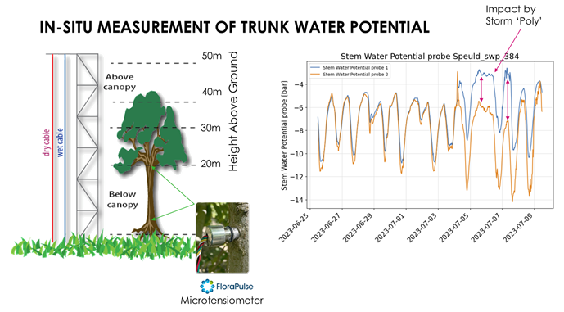

Credit: Yijian Zeng

# Grape – Wine and Table

Performance:

* Recommended for experimental and commercial use.
* Sensor readings generally correlate well against the pressure chamber.

Installation tips:

* Sensors must be installed into vines that are large enough and healthy. Big probes should be installed in trunks > 2”.
* Consider taking a core sample of nearby vines to ensure xylem is healthy. This is especially important if the vines are exposed to conditions that damage the xylem: trunk diseases (Eutypa, black foot, etc.), heavy water stress for years, sub-freezing temperatures.
* Generally recommend using the small 3 mm sensor, and installing into vines that are at least 15 mm in trunk diameter.
* Sensors should be installed after leaf-out and replaced each year.

Troubleshooting:

* Sensors can get disconnected from xylem due to breaks in the mating compound. The sensors will then read very negative values during the hottest part of day. Reinstall.
* Sensor data will be non-sensical if sensors are installed into damaged/diseased/inactive part of wood. If your vineyard has lots of wood disease, consider installing sensors into younger vines that may be healthier.

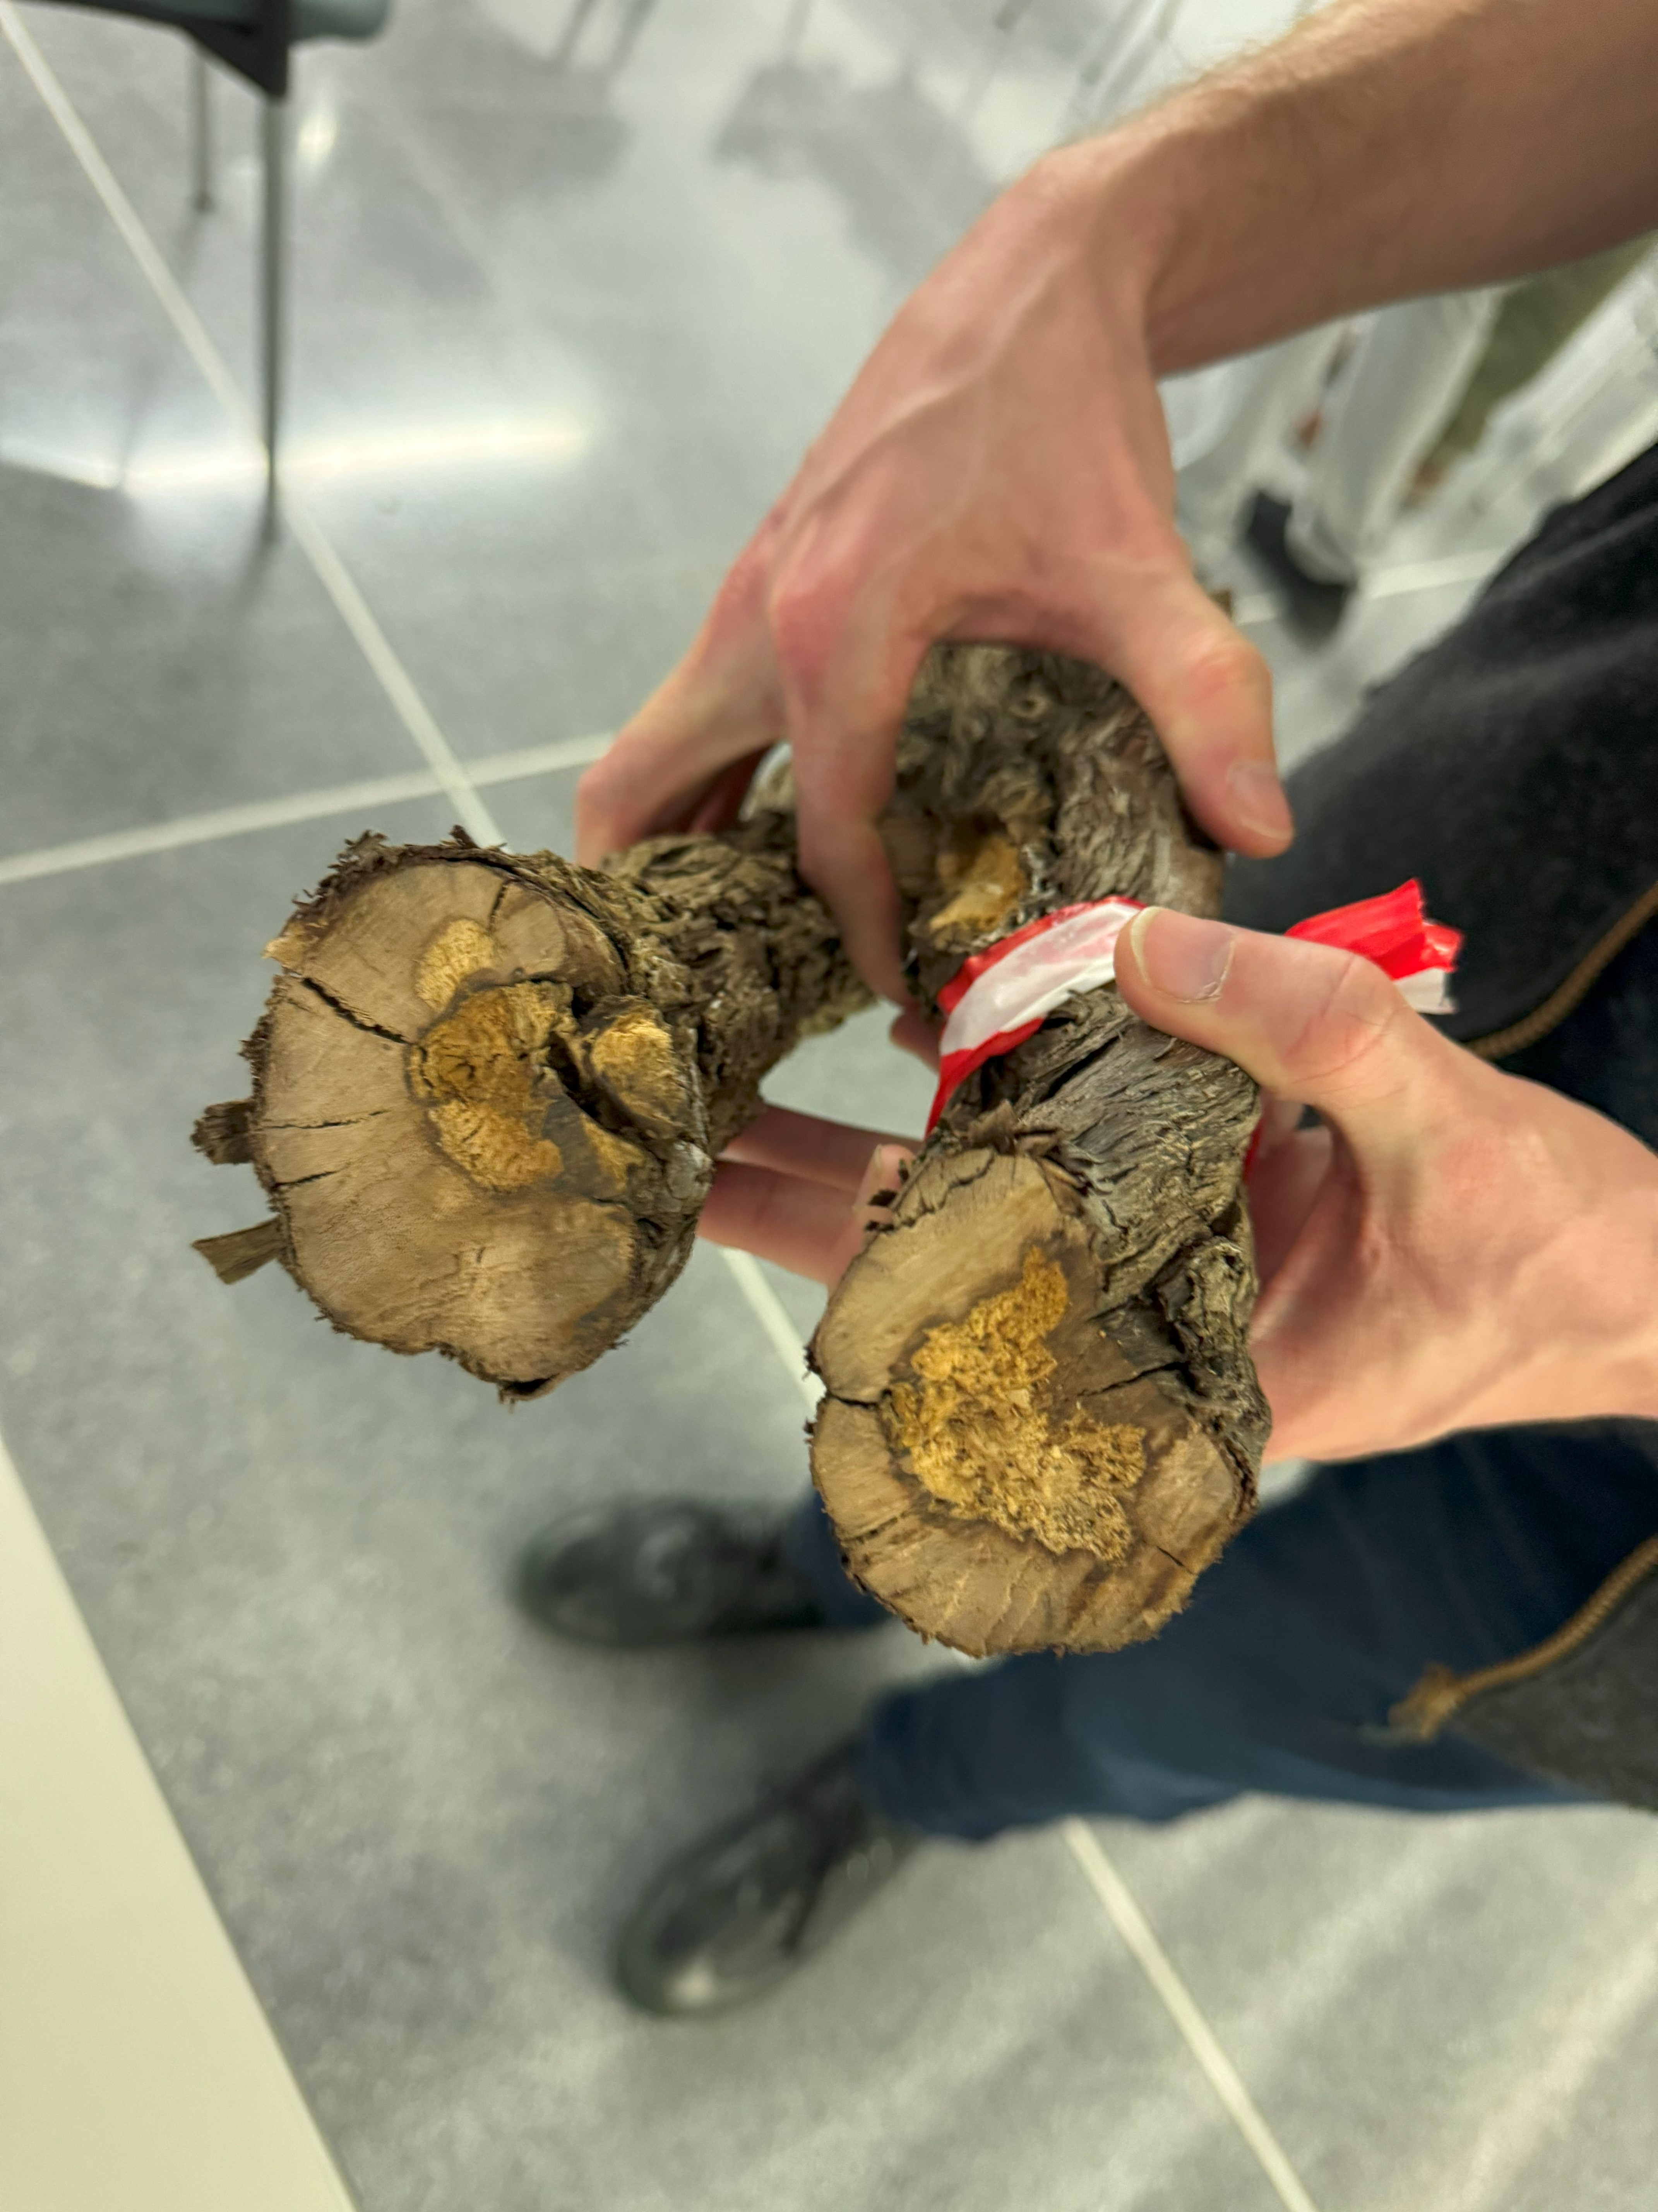

Figure 2. Trunk disease will prevent accurate SWP readings.

References:

* Scheduling irrigation with a pressure chamber. [Part 1](https://www.youtube.com/watch?v=uABpZfRnau0). [Part 2](https://www.youtube.com/watch?v=s1GJUgvx7t4).

# Grapefruit

Performance:

* Testing

# Hazelnut

Performance:

* Recommended for experimental use.
* Initiial testing showed good correlation with the pressure chamber.

# Kiwi

Performance:

* Recommended for experimental use.
* Initial testing showed mixed results – some sensor installations performed well, whereas others appeared to get flooded.
* FloraPulse is looking for a partner to test in kiwi in California.

# Lemon

Performance:

* Testing

# Lime

Performance:

* Untested

# Lychee/longan

Performance:

* Untested.

# Macadamia

Performance:

* Untested.

# Mandarin orange

Performance:

* Recommended for experimental use.
* One commercial tester stated he “was happy with the data. Although he noted there was a fixed offset when compared to bomb measurements, the correlation made sense”.

# Mango

Performance:

* Recommended for experimental and initial commercial use.
* Sensor testing by commercial grower was successful and met customer expectations.
* Correlation against the pressure bomb has not been tested, and irrigation thresholds are undeveloped. Recommend irrigating according to the sensor trend and past experience.

Troubleshooting:

* Mango trees produce latex. This is generally not an issue, but can happen if the sensors are not installed deeply enough. If sensors begin to read zero for more than a couple of days, recommend reinstalling them.

# Maple

Performance:

* Not tested. It is possible that sensors may flood due to well-known sweet maple sap.
* Heading cut type install could give good data in this species.

Installation tips:

* Thick bark may necessitate using the thick-bark installation method.

# Oak

Performance:

* Untested.

# Olive

Performance:

* Recommended for experimental and commercial use.
* Favorable comparison with the pressure chamber.

Installation tips:

* Do not use in fields where SWP is expected to drop below -35 bars.

Troubleshooting:

* Depending on the region, olive trees are water stressed to -60 bars or lower. Under such negative water potentials, FloraPulse sensors will invariably cavitate and become unusable. We thus only recommend installing FloraPulse sensors where SWP is generally above -35 bars.

References:

* [Establishing a Reference Baseline for Midday Stem Water Potential in Olive and Its Use for Plant-Based Irrigation Management](https://www.frontiersin.org/journals/plant-science/articles/10.3389/fpls.2021.791711/full)

# Orange

Performance:

* Testing

# Peach/nectarine

Performance:

* Recommended for experimental and initial commercial use.
* Initial testing showed favorable results, but more testing needed.

References:

* Plant water stress derived indexes from water potential and diameter fluctuations measurements. Conesa 2023

# Pear

Performance:

* Recommended for experimental and commercial use.
* Favorable comparison with the pressure chamber.

References:

* Microtensiometers Accurately Measure Stem Water Potential in Woody Perennials

# Pecan

Performance:

* Not recommended at the moment.
* Normal installations get flooded due to excessive sap production at the installation site.
* Heading cut install will be tested to see if it solves the issue.

# Pepper (Bell pepper tested)

Performance:

* Recommended for experimental and initial commercial use.
* First season field trial showed good correlation with the pressure chamber.

Install tips:

* Recommend using the 3mm small sensor for this crop due to the small trunk size.

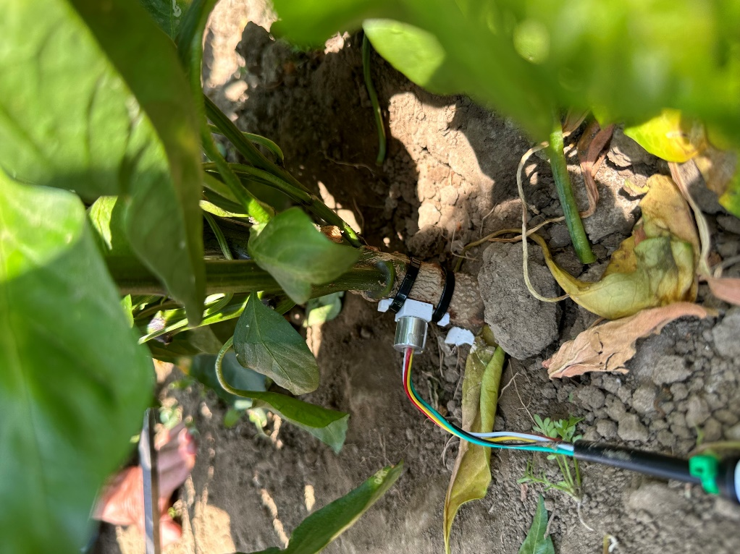 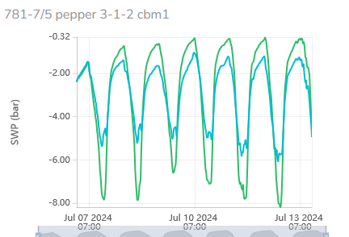

Pepper installation with 3D printed jig that holds the sleeve in place.

# Persimmon

Performance:

* Not recommended.
* Black oozing from sensor wound prevents measurement.

# Pine

Performance:

* Initial testing shows sensor can work relatively well for at least 2+ weeks (testing is ongoing).

Installation tips:

* Will need thick-bark installation method.
* There is concern about resin ducts blocking the sensor measurement. Uncertain if tree exudates will actually cause problems.

# Pistachio

Performance:

* Recommended for experimental use.
* Field trials show good agreement between the sensor and pressure chamber.
* Sensors sometimes randomly get flooded and proceed to measure zero SWP. Reinstalling the sensor will usually fix this. We are testing to better understand what causes this wounding response and how to prevent it.

Troubleshooting:

* Pistachio trees produce latex, which can (randomly) interfere with sensor measurement. Sensors should be reinstalled if they get stuck at zero SWP.

# Pomegranate

Performance:

* Untested.

# Pomelo

Performance:

* Untested

# Prune/plum

Performance:

* Excellent. Recommended for commercial use.
* Sensor data generally matches the pressure chamber.
* Thoroughly validated and used commercially.

Installation tips:

* Install after leaf out, on a 2” branch. Installation into main trunk can be difficult if the bark is thick. Big and small sensors can work well.
* Sensors should be reinstalled after the winter, otherwise measured SWP will be incorrectly wetter.

Troubleshooting:

* Sensor install site can get blocked and sensor will read too wet, with little to no diurnal pattern. Reinstall.
* Sensors can get disconnected from xylem due to breaks in the mating compound. The sensors will then read very negative values during hot part of day. Reinstall.
* Very old or diseased prune trees will sometimes give nonsensical data, such as reading the lowest SWP at night. If this happens, sensors should be installed in a different tree.

Guidelines:

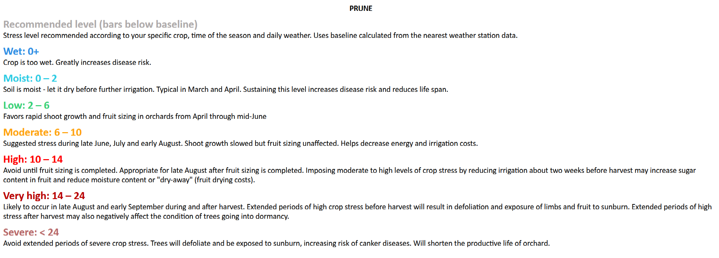

References:

* [Using the Pressure Chamber for Irrigation Management in Walnut, Almond, and Prune](https://anrcatalog.ucanr.edu/pdf/8503.pdf)

# Redwoods

Performance:

* Very good. Initial testing shows strong sensor-sensor agreement and consistent diurnals. Recommended for experimental use.

Installation tips:

* Redwood bark can be over 2” thick. You will need to use the thick-bark installation method.
* Be careful with sensors installed in freezing-prone areas. Temperatures below zero can damage the sensors.

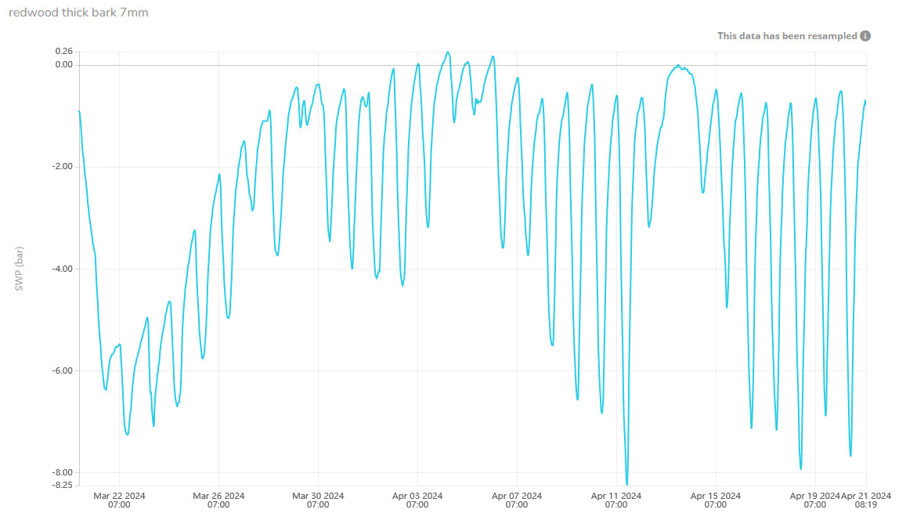

# Soil

Performance:

* Microtensiometer sensors not recommended for use in soil. The existing installation method does not translate well to soil installation and would give inaccurate data. Furthermore, the sensor resolution of ~0.2 bars is too coarse for most soil applications, where the full range is often 0 – 1 bar.
* It’s likely possible to use microtensiometers to measure WP in very dry soils, but the installation method needs development.

# Soybean

Performance:

* Untested.

# Spruce

Performance:

* Recommended for experimental use.
* Initial trials showed sensors perform well and correlate favorably with the pressure chamber.

Install tips:

* Will need to use thick-bark install method.

Troubleshooting:

* Freezing temperatures may damage the sensor.

# Tobacco

Performance:

* Initial trial started.

# Tomatoes

Performance:

* Small probes installed shallowly give reasonable data and agree with each other.
* Recommended for experimental use.

Installation tips:

* Installation requires care because tomato trunks are soft and small.

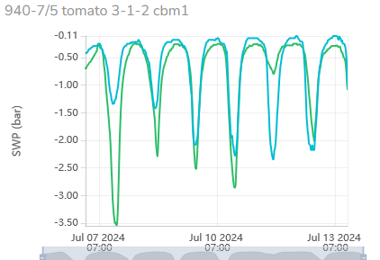

# Walnut

Performance:

* Not recommended at the moment.
* Normal sensor installations get flooded after a few days and measure zero SWP indefinitely.
* The new heading cut install appears promising and we are testing it this season.